ARTI 308 – Machine Learning
Term 2 – 2025/2026
Project Progress Report
✓ Group #: 4
✓ Members of the group: 6
# | Name | ID | Role
1 | Wesam Jaber Almalki | 2240005660 | Leader
2 | Fahad Nawar Alotaibi | 2240002024 | Member
3 | Fawaz Alshahrani | 2240005571 | Member
4 | Faris Alshahrani | 2240005572 | Member
5 | Ahmed Albouainain | 2240006128 | Member
6 | Anas Hamzi | 2240003869 | Member

✓ Title of the Project :Unsupervised Disease Subgroup Discovery from Health Data

Abstract
Chronic diseases such as hypertension, obesity, and diabetes represent major public health challenges worldwide, yet discovering meaningful patient subgroups from health data without predefined labels remains an open analytical problem. This progress report presents the current state of an unsupervised machine learning framework designed to discover disease subgroups directly from health and dietary indicators, without relying on labeled datasets. The motivation behind this work arises from the increasing availability of health-related data alongside the limitations of traditional supervised analysis methods that depend on predefined disease classifications. Previous studies have primarily focused on disease-specific outcomes using supervised approaches or targeted narrow population groups, leaving a gap in general-purpose, label-free disease subgroup discovery from multi-dimensional health data. To address this gap, the proposed approach employs data preprocessing, feature engineering, and four clustering algorithms: K-Means, Hierarchical Clustering (Ward linkage), DBSCAN, and Gaussian Mixture Models (GMM). Dimensionality reduction via PCA and t-SNE is used for visualization. Experimental results on a 1,000-record health dataset demonstrate that GMM achieves the best clustering performance with a Silhouette Score of 0.1097 and a Davies-Bouldin Index of 2.4997. Post-hoc validation against known disease labels reveals cluster purities of up to 97.5% for the Hypertension subgroup. A feature sensitivity analysis further demonstrates that reducing the feature space to three key biomarkers (BMI, Glucose, Blood Pressure) dramatically improves separation, achieving a Silhouette Score of 0.3649. These findings confirm the viability of unsupervised learning for disease subgroup discovery and support future work in personalized health analytics.
Keywords: Unsupervised Learning, Disease Subgroup Discovery, K-Means Clustering, Gaussian Mixture Model, Dimensionality Reduction

1. Introduction
Chronic diseases such as hypertension, obesity, and diabetes are among the leading causes of morbidity and mortality worldwide. With the rapid advancement of electronic health records, wearable technologies, and large-scale health surveys, massive volumes of patient health data—including clinical biomarkers, dietary intake, and lifestyle indicators—are continuously being generated. Despite this growth, discovering meaningful disease subgroups from such multi-dimensional data remains a significant analytical challenge, particularly when reliable diagnostic labels are unavailable or incomplete [1][2].
This project introduces an unsupervised disease subgroup discovery framework that applies machine learning techniques to identify latent patient clusters directly from health indicators, without relying on predefined disease labels. The primary aim is to let natural groupings emerge from the data itself, rather than imposing supervised classification boundaries. This approach addresses the limitations of traditional diagnostic models, which require extensive labeled datasets and may introduce bias through predefined assumptions about disease categories [3][4].
Previous studies have explored health data analysis using both statistical and supervised machine learning approaches. Tatoli et al. [1] demonstrated the effectiveness of unsupervised learning in identifying dietary patterns linked to diabetes in Southern Italy. Li et al. [2] applied machine learning to a Japanese cohort to study dietary patterns associated with hypertension. Sun et al. [3] used machine learning to associate dietary patterns with type 2 diabetes risk in elderly Chinese men. Gjoreski et al. [4] explored dietary intake data using unsupervised methods, while Côté et al. [5] used complex network-based algorithms to link dietary behaviors with cardiovascular risks. D’Souza et al. [6] compared various unsupervised methods to understand lifestyle behaviors in children.
While these efforts have provided valuable contributions, they typically depend on labeled datasets and predefined target variables, or focus on disease-specific outcomes within narrow population groups (e.g., elderly, children, or single-gender cohorts). There remains a clear need for exploratory, data-driven approaches capable of discovering disease subgroups from general health data without prior labeling.
The proposed work employs data preprocessing, feature engineering, and four clustering algorithms—K-Means, Hierarchical Clustering (Ward linkage), DBSCAN, and Gaussian Mixture Models (GMM)—along with dimensionality reduction techniques (PCA and t-SNE) to identify meaningful disease subgroups from health indicators. The envisioned outcome is a scalable, label-free analytical framework that can discover clinically interpretable patient clusters and support future research in personalized medicine and public health decision-making.
The remaining part of this work is organized as follows. Section 2 contains a review of related literature. Section 3 describes the proposed machine learning techniques. Section 4 contains the empirical studies including dataset description, experimental setup, and performance measures. Section 5 presents results and discussion, while Section 6 contains the conclusion and future work.

2. Review of Related Literature
Recent advancements in machine learning have enabled researchers to move beyond traditional dietary analysis. Several studies have demonstrated the effectiveness of unsupervised learning in identifying dietary patterns linked to chronic diseases across different global populations.
Tatoli et al. [1] applied unsupervised learning techniques to analyze dietary patterns associated with diabetes in an older population from Southern Italy. Their study identified distinct dietary clusters that correlated with metabolic health markers, demonstrating how clustering methods can reveal diet-disease relationships without predefined labels.
Li et al. [2] investigated dietary patterns associated with hypertension incidence among adult Japanese males using machine learning applied to a cohort study. Their work highlighted how data-driven clustering approaches can identify dietary risk factors in specific demographic groups.
Sun et al. [3] used a machine learning approach to study the association between dietary patterns, obesity, and type 2 diabetes risk in elderly Chinese men. Their findings confirmed the utility of computational methods in uncovering dietary correlations with chronic conditions.
Gjoreski et al. [4] explored dietary intake data collected by food propensity questionnaires using unsupervised learning at an IEEE Big Data conference. This study further highlighted the ability of such methods to uncover hidden patterns without predefined labels.
Côté et al. [5] utilized complex network-based algorithms to link dietary behaviors with cardiovascular risks in the NutriNet-Santé cohort, published in The Journal of Nutrition (2025). Their approach demonstrated that network-derived dietary patterns could identify cardiovascular risk factors.
D’Souza et al. [6] compared children’s diet and movement behavior patterns derived from three unsupervised multivariate methods in PLoS ONE (2021). This comparative study provided insights into methodology selection for behavioral pattern analysis.
Table 1: Summary of Related Literature
Ref. | Authors (Year) | Focus Area | Method | Population | Gap
[1] | Tatoli et al. (2022) | Diabetes & dietary patterns | Unsupervised learning | Elderly, Southern Italy | Disease-specific, limited population
[2] | Li et al. (2024) | Hypertension & diet | ML on cohort study | Adult Japanese males | Single-gender, single-disease focus
[3] | Sun et al. (2025) | Obesity, T2D & diet | ML approach | Elderly Chinese men | Narrow demographic group
[4] | Gjoreski et al. (2019) | Dietary intake via FPQ | Unsupervised learning | General | Limited to questionnaire data
[5] | Côté et al. (2025) | CVD risk & diet networks | Network-based ML | NutriNet-Santé cohort | Cardiovascular-specific outcomes
[6] | D’Souza et al. (2021) | Children’s diet & movement | 3 unsupervised methods | Children | Age-limited scope

Although these studies provide valuable insights, they are often limited in scope and generalizability. Most existing research focuses on disease-specific outcomes such as diabetes or obesity, or targets specific population groups such as the elderly or children. There is still a lack of studies that explore dietary habits in a general population context without relying on predefined health labels or assumptions.
Therefore, a clear research gap exists in applying unsupervised learning techniques to analyze broader and more diverse dietary data. This project aims to address this gap by applying clustering methods such as K-Means along with dimensionality reduction techniques like PCA to uncover latent dietary patterns. The goal is to provide a purely data-driven classification of eating behaviors that can support personalized lifestyle recommendations, rather than focusing solely on clinical diagnosis.
Table 2: Identified Research Gaps
Gap | Present in Literature?
General population analysis (not disease-specific) | ✗
Label-free exploratory dietary profiling | ✗
Multi-algorithm comparison on same dietary data | ✗
Feature sensitivity analysis for dietary biomarkers | ✗
Integration of dimensionality reduction with clustering | ✓ (partial)

3. Description of the Proposed Techniques
This section describes the four unsupervised learning techniques employed in this project. The selection spans partition-based, hierarchical, density-based, and probabilistic paradigms to provide a comprehensive comparison.

3.1 K-Means Clustering
K-Means is a partition-based clustering algorithm that divides the dataset into K clusters by minimizing the within-cluster sum of squares (inertia). The algorithm iteratively assigns each data point to the nearest centroid and recalculates centroids until convergence. K-Means is computationally efficient and works well with spherical, equally-sized clusters. The optimal number of clusters K is determined using the Elbow Method, Silhouette Score, and Davies-Bouldin Index, supplemented by domain knowledge (three known disease groups). For further details, readers are referred to MacQueen (1967) and Arthur & Vassilvitskii (2007).

3.2 Hierarchical Clustering (Ward Linkage)
Hierarchical Agglomerative Clustering (HAC) builds a tree-like hierarchy of clusters by iteratively merging the two closest clusters. Ward’s linkage minimizes the total within-cluster variance at each merge step. Unlike K-Means, hierarchical clustering does not require specifying K in advance; the dendrogram visualization allows inspection of the merging process and selection of an appropriate cut level. This method is particularly useful for understanding the nested structure of dietary behavior groups. For more details, readers are referred to Ward (1963) and Müllner (2011).

3.3 DBSCAN (Density-Based Spatial Clustering)
DBSCAN groups together points that are closely packed in high-density regions, marking outliers in low-density areas as noise. It requires two parameters: eps (neighborhood radius) and min_samples (minimum points to form a dense region). Unlike K-Means, DBSCAN does not require specifying the number of clusters and can discover clusters of arbitrary shape. The eps parameter is selected using the k-distance graph. For further details, readers are referred to Ester et al. (1996).

3.4 Gaussian Mixture Model (GMM)
GMM is a probabilistic soft-clustering model that assumes the data is generated from a mixture of Gaussian distributions. Each data point is assigned a probability of belonging to each cluster, rather than a hard assignment. This makes GMM better suited for overlapping groups, such as patients with comorbid conditions (e.g., obesity and diabetes sharing metabolic features). Model selection uses the Bayesian Information Criterion (BIC) and Akaike Information Criterion (AIC). For further details, readers are referred to McLachlan & Peel (2000).

4. Empirical Studies

4.1 Description of Dataset
The dataset used in this project is a diet recommendations dataset containing 1,000 patient records with 15 attributes. It includes demographic information (Age, Gender), anthropometric measurements (Weight, Height, BMI), clinical biomarkers (Cholesterol, Blood Pressure, Glucose), dietary indicators (Daily Caloric Intake, Dietary Nutrient Imbalance Score), behavioral measures (Weekly Exercise Hours, Adherence to Diet Plan), and categorical attributes (Disease Type, Preferred Cuisine). The Disease Type attribute contains three classes: Hypertension (398 records), Obesity (393 records), and Diabetes (209 records). The dataset has no missing values.
4.1.1 Statistical Analysis of the Dataset
Table 3: Statistical Analysis of the Dataset
Feature | Mean | Std Dev | Min | 25% | 50% | 75% | Max
Age | 49.86 | 18.11 | 18.00 | 35.00 | 50.00 | 66.00 | 79.00
BMI | 28.19 | 8.04 | 13.00 | 22.08 | 27.45 | 33.42 | 52.40
Daily Caloric Intake | 2475.06 | 565.02 | 1500.00 | 1984.75 | 2470.50 | 2937.25 | 3498.00
Cholesterol (mg/dL) | 226.10 | 13.51 | 200.30 | 214.38 | 227.60 | 237.72 | 248.90
Blood Pressure (mmHg) | 149.26 | 13.06 | 125.00 | 139.00 | 149.00 | 159.00 | 179.00
Glucose (mg/dL) | 118.69 | 25.39 | 85.10 | 101.00 | 111.45 | 131.18 | 199.80
Weekly Exercise Hours | 5.17 | 2.85 | 0.00 | 2.80 | 5.20 | 7.60 | 10.00
Adherence to Diet Plan | 74.88 | 14.83 | 50.00 | 62.00 | 74.20 | 88.20 | 100.00
Nutrient Imbalance Score | 2.47 | 1.46 | 0.00 | 1.20 | 2.40 | 3.70 | 5.00

Table 4: Key Correlations Between Features
Feature Pair | Correlation Coefficient
Weight_kg and BMI | 0.80
Height_cm and BMI | -0.53
Blood_Pressure_mmHg and Glucose_mg/dL | -0.29
Weight_kg and Glucose_mg/dL | 0.32
Blood_Pressure_mmHg and BMI | -0.25
Blood_Pressure_mmHg and Weight_kg | -0.26
The high correlation between Weight_kg and BMI (r = 0.80) justified removing Weight_kg from the feature set to avoid redundancy. Height_cm was also removed due to near-zero correlation with most features.

4.2 Experimental Setup
All experiments were conducted using Python 3.x in Jupyter Notebook / Google Colab. The key libraries used include: Pandas and NumPy for data manipulation, Scikit-Learn for implementing clustering algorithms (K-Means, Agglomerative Clustering, DBSCAN, Gaussian Mixture Model) and dimensionality reduction (PCA, t-SNE), SciPy for hierarchical clustering linkage and dendrogram computation, and Matplotlib/Seaborn for visualization.
The experimental procedure followed these steps:
Step 1 – Data Loading and EDA: The dataset (1,000 records, 15 columns) was loaded and inspected for missing values (none found). Exploratory analysis examined categorical distributions and numerical correlations.
Step 2 – Preprocessing: Patient_ID was dropped as an identifier. Disease_Type was set aside for post-hoc validation only. Gender and Preferred_Cuisine were excluded as they have no medical link to disease groups. Weight_kg was removed due to high correlation with BMI (r = 0.80), and Height_cm was removed due to near-zero correlation with other features. The final feature set consists of 9 numerical features standardized using StandardScaler (zero mean, unit variance).
Step 3 – Dimensionality Reduction: PCA was applied to determine that all 9 components are needed for 95% variance. PCA and t-SNE were used to project data to 2D for visualization.
Step 4 – Clustering: Four algorithms were applied: K-Means (K=2 to 10 sweep, final K=3), Hierarchical Clustering (Ward linkage, K=3), DBSCAN (eps sweep from 40th to 90th percentile of k-distances, min_samples=10), and GMM (3 components, full covariance).
Step 5 – Evaluation: Silhouette Score, Davies-Bouldin Index, and Inertia were computed. Post-hoc validation compared discovered clusters against known Disease_Type labels. Feature sensitivity analysis was conducted with 3 key biomarkers.
Figure 1 below illustrates the overall experimental framework:
Data Collection → EDA → Preprocessing → Feature Selection → Standardization → Dimensionality Reduction (PCA/t-SNE) → Clustering (K-Means, Hierarchical, DBSCAN, GMM) → Evaluation & Profiling

4.3 Performance Measures
Since this project focuses on unsupervised learning, traditional supervised metrics such as accuracy or F1-score are not applicable. The following internal validation metrics are used, consistent with the evaluation strategies found in the literature [1][4][6]:
Silhouette Coefficient: Measures how similar a point is to its own cluster compared to neighboring clusters. Values range from -1 to +1, with higher values indicating better-defined clusters.
Davies-Bouldin Index (DBI): Evaluates the average similarity between each cluster and its most similar one. Lower values indicate better separation and compactness.
Inertia (Within-Cluster Sum of Squares): Measures how tightly data points are grouped around their cluster centroids. Used with the Elbow Method to determine optimal K.
BIC/AIC (for GMM): Bayesian and Akaike Information Criteria measure model fit while penalizing complexity.
Post-hoc Validation: Cross-tabulation of discovered clusters against known Disease_Type labels to assess cluster purity and interpretability.

5. Results and Discussion

5.1 Exploratory Data Analysis
The dataset contains balanced representation across disease types: Hypertension (398), Obesity (393), and Diabetes (209). Gender distribution and cuisine preferences are also approximately balanced. The correlation heatmap revealed that Weight_kg and BMI share a strong positive correlation (r = 0.80), while Blood Pressure and Glucose show a moderate negative correlation (r = -0.29).
Figure 1: Categorical Feature Distributions
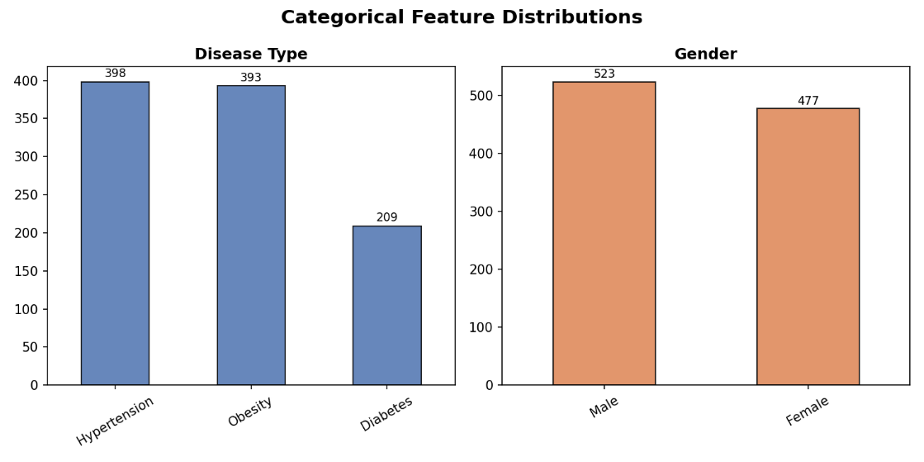

Figure 2: Correlation Matrix
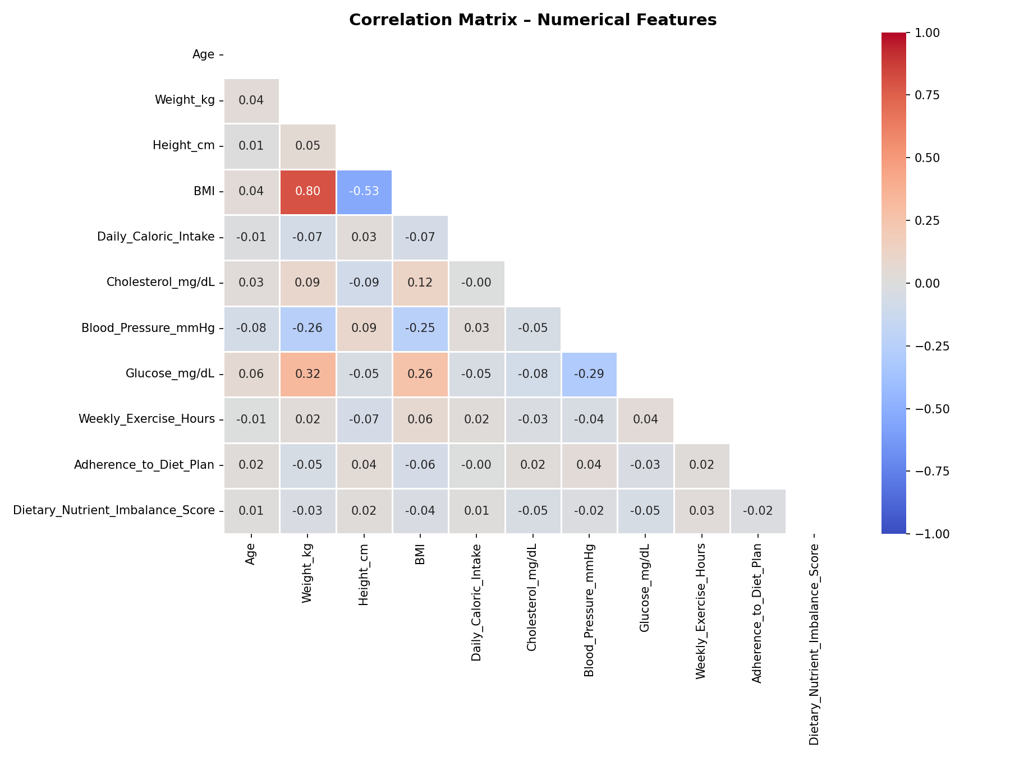

5.2 Dimensionality Reduction
PCA analysis revealed that all 9 principal components are required to explain 95% of the total variance, indicating that the features carry relatively independent information. The first two components explain only 29.9% of variance, suggesting substantial information exists across multiple dimensions. This motivates the use of t-SNE alongside PCA for 2D visualization.
Figure 3: PCA Cumulative Explained Variance
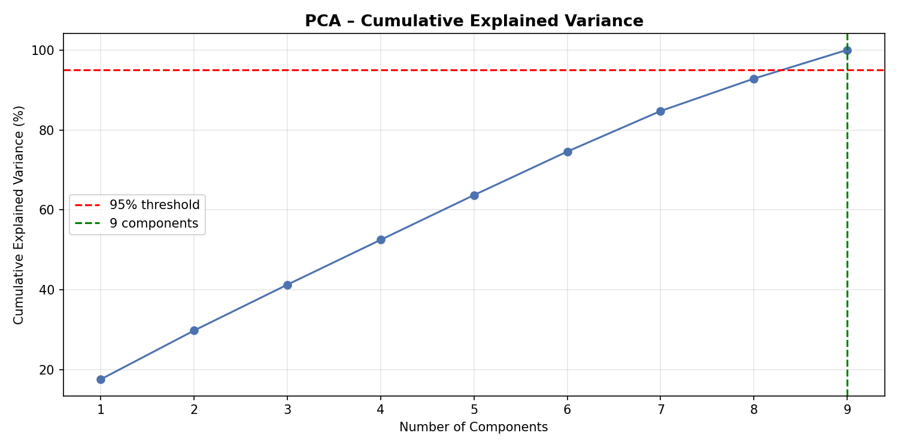

5.3 K-Means Clustering Results
The K-Means model selection process evaluated K values from 2 to 10. While the Elbow Method did not reveal a sharp elbow, K=3 was selected based on domain knowledge (three disease groups: Hypertension, Obesity, Diabetes). The final K-Means model (K=3) achieved a Silhouette Score of 0.1071 and a Davies-Bouldin Index of 2.5714 with an Inertia of 7285.74.
Figure 4: K-Means Model Selection Metrics
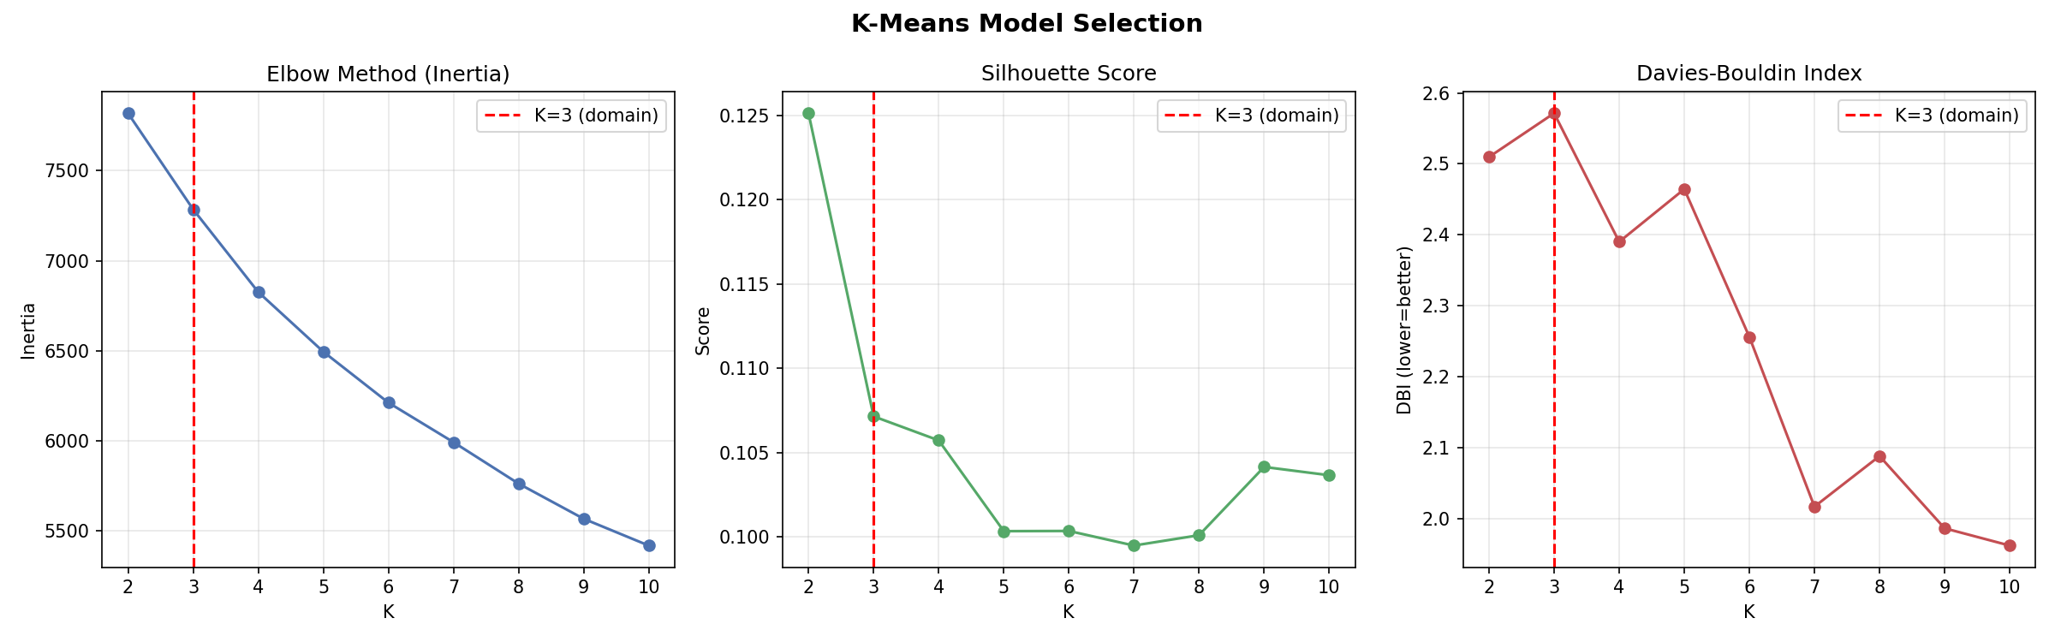

Figure 5: K-Means Clusters (PCA and t-SNE Projections)
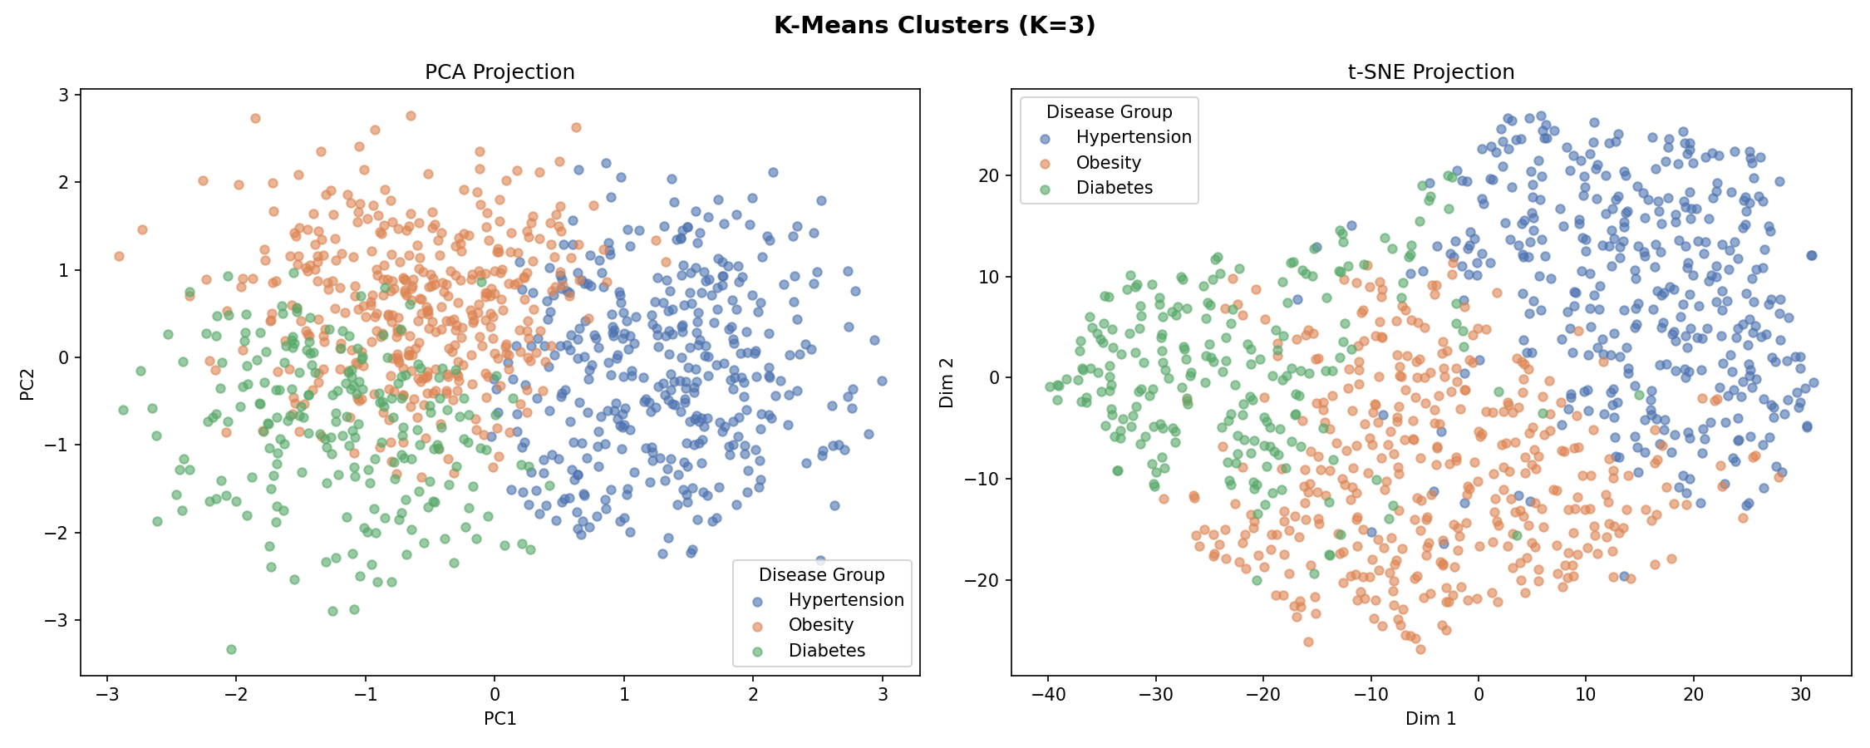

5.4 Hierarchical Clustering Results
Hierarchical Agglomerative Clustering with Ward linkage was applied with K=3. A dendrogram was generated from a 200-sample subset for readability. The model achieved a Silhouette Score of 0.0984 and a Davies-Bouldin Index of 2.6234, performing slightly below K-Means on both metrics.
Figure 6: Hierarchical Clustering Dendrogram
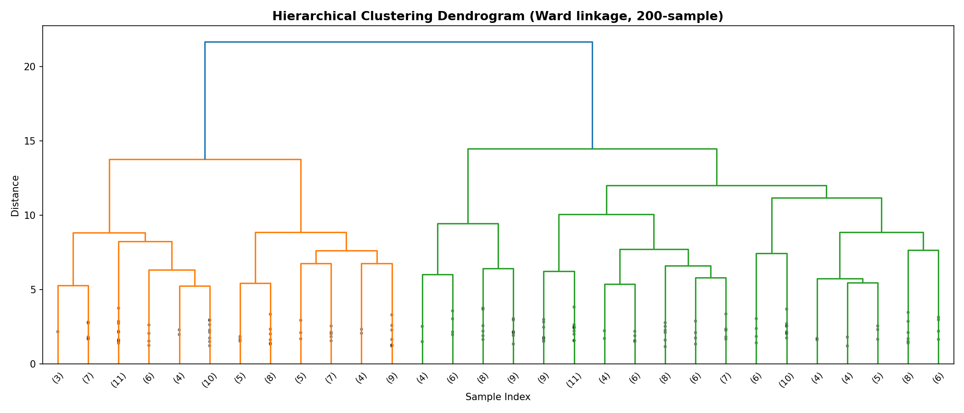

Figure 7: Hierarchical Clusters (PCA and t-SNE Projections)
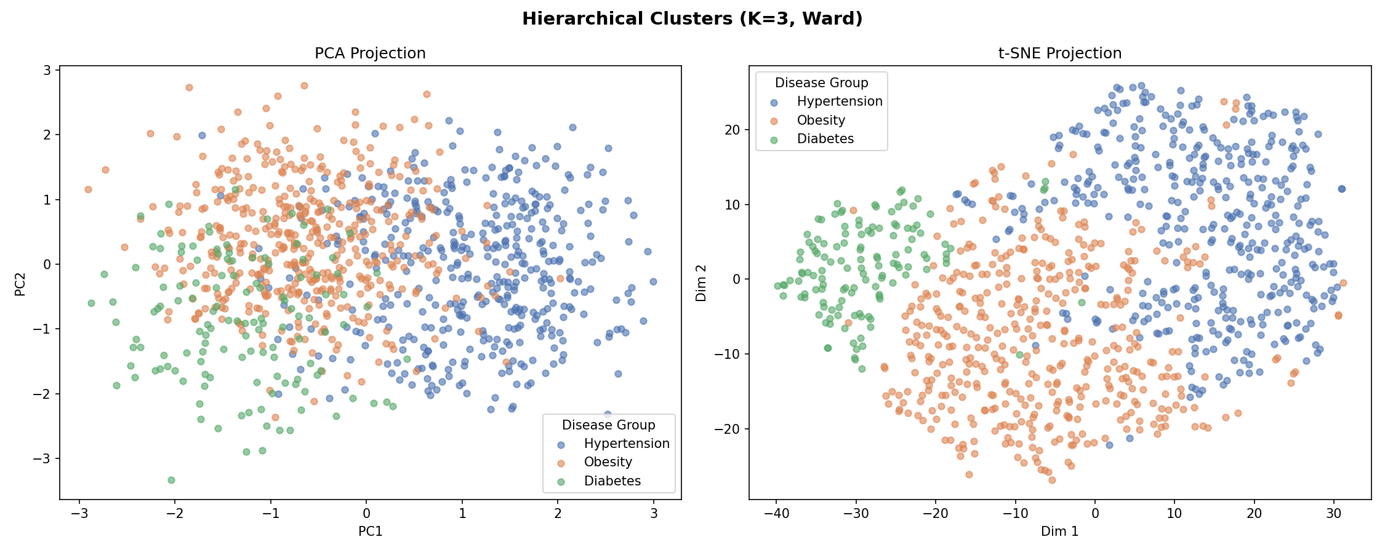

5.5 DBSCAN Results
DBSCAN was applied with min_samples=10 and eps values swept from the 40th to 90th percentile of k-distances. Across all tested eps values, DBSCAN consistently found only 1 cluster, with noise points decreasing from 144 (at eps=2.013) to 2 (at eps=2.413). This indicates the data has uniform density with no natural density-based separations. DBSCAN is therefore not suited for this particular dataset, confirming that partition-based and probabilistic methods are more appropriate.
Figure 8: DBSCAN k-Distance Graph
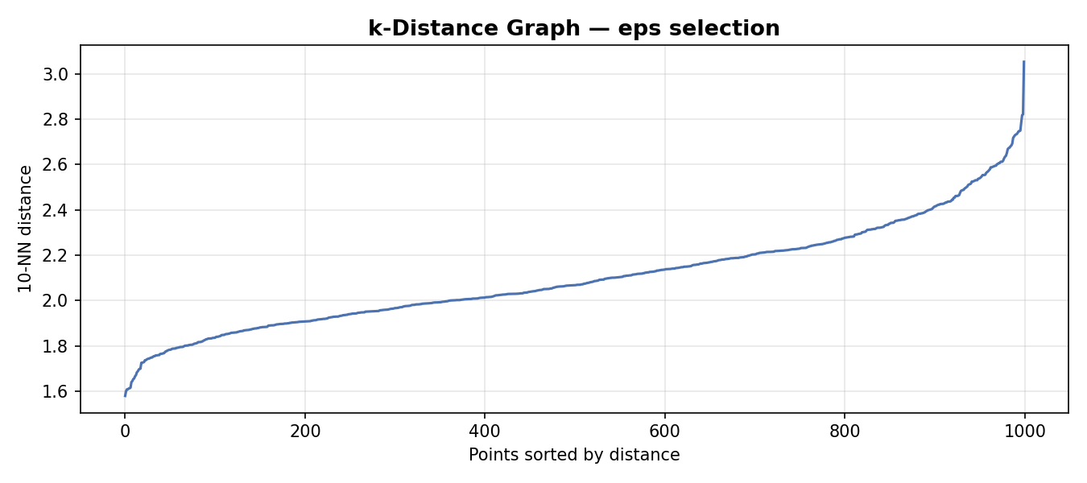

Figure 9: DBSCAN Clustering Result
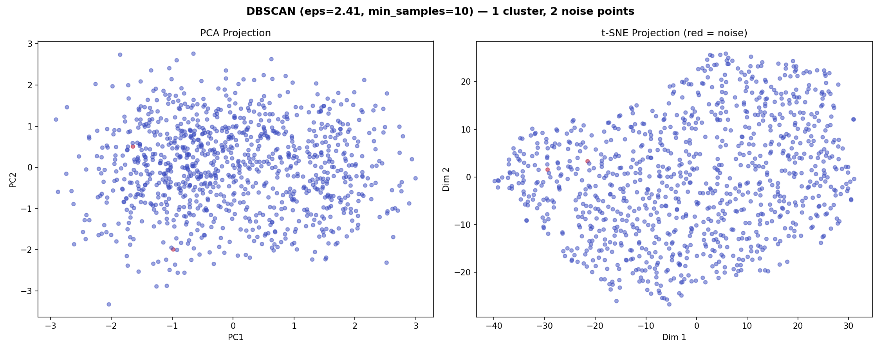

5.6 Gaussian Mixture Model Results
GMM with 3 components and full covariance achieved the best performance among all algorithms, with a Silhouette Score of 0.1097 and a Davies-Bouldin Index of 2.4997. The BIC was 25089.39 and AIC was 24284.52. The mean maximum probability per point was 0.934, indicating high confidence in cluster assignments. Post-hoc validation showed that the Hypertension cluster achieved 97.5% purity (390/400), the Diabetes cluster achieved 88.4% purity (152/172), and the Obesity cluster achieved 87.1% purity (373/428).
Figure 10: GMM Clusters (PCA and t-SNE Projections)
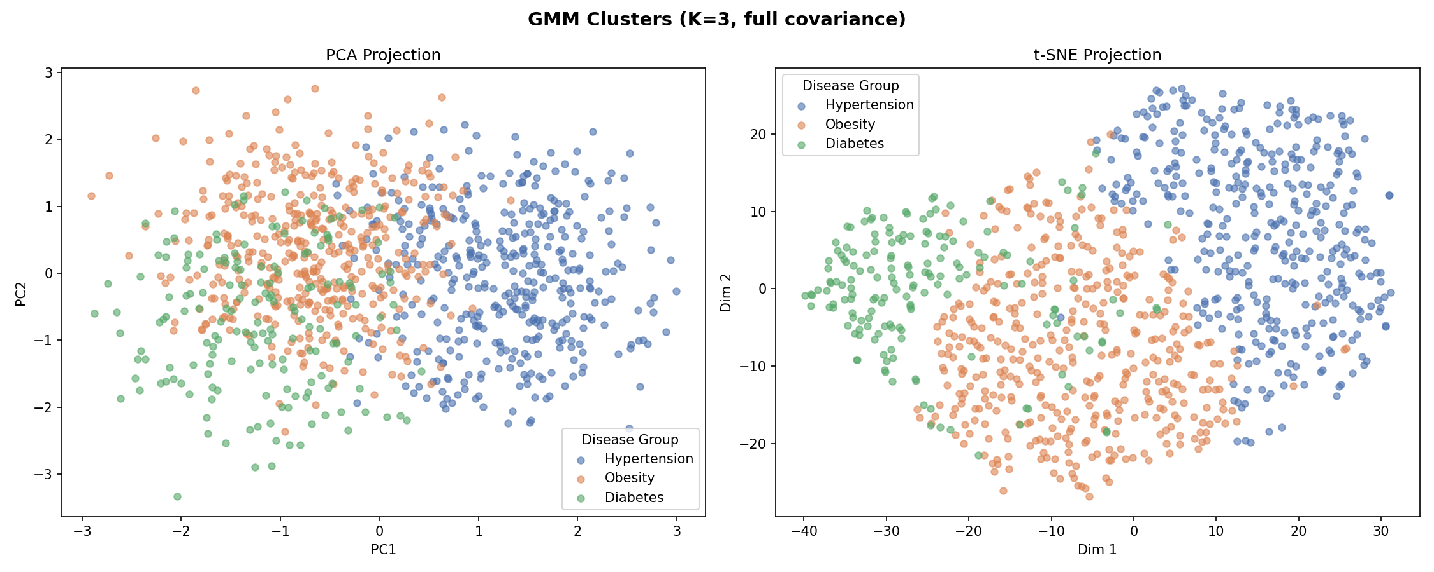

Table 5: GMM Post-hoc Validation – Discovered Clusters vs. Actual Disease Type
Discovered Group | Diabetes | Hypertension | Obesity | Total
Cluster → Diabetes | 152 | 0 | 20 | 172
Cluster → Hypertension | 10 | 390 | 0 | 400
Cluster → Obesity | 47 | 8 | 373 | 428

5.7 Algorithm Comparison
Table 6: Algorithm Comparison Summary
Algorithm | Clusters | Silhouette Score | Davies-Bouldin Index
K-Means | 3 | 0.1071 | 2.5714
Hierarchical (Ward) | 3 | 0.0984 | 2.6234
GMM | 3 | 0.1097 | 2.4997
DBSCAN | 1 | N/A | N/A
GMM (highlighted in green) achieved the best Silhouette Score (0.1097) and the lowest Davies-Bouldin Index (2.4997) among the applicable algorithms, making it the best-performing model for this dataset.
Figure 11: Algorithm Comparison Charts
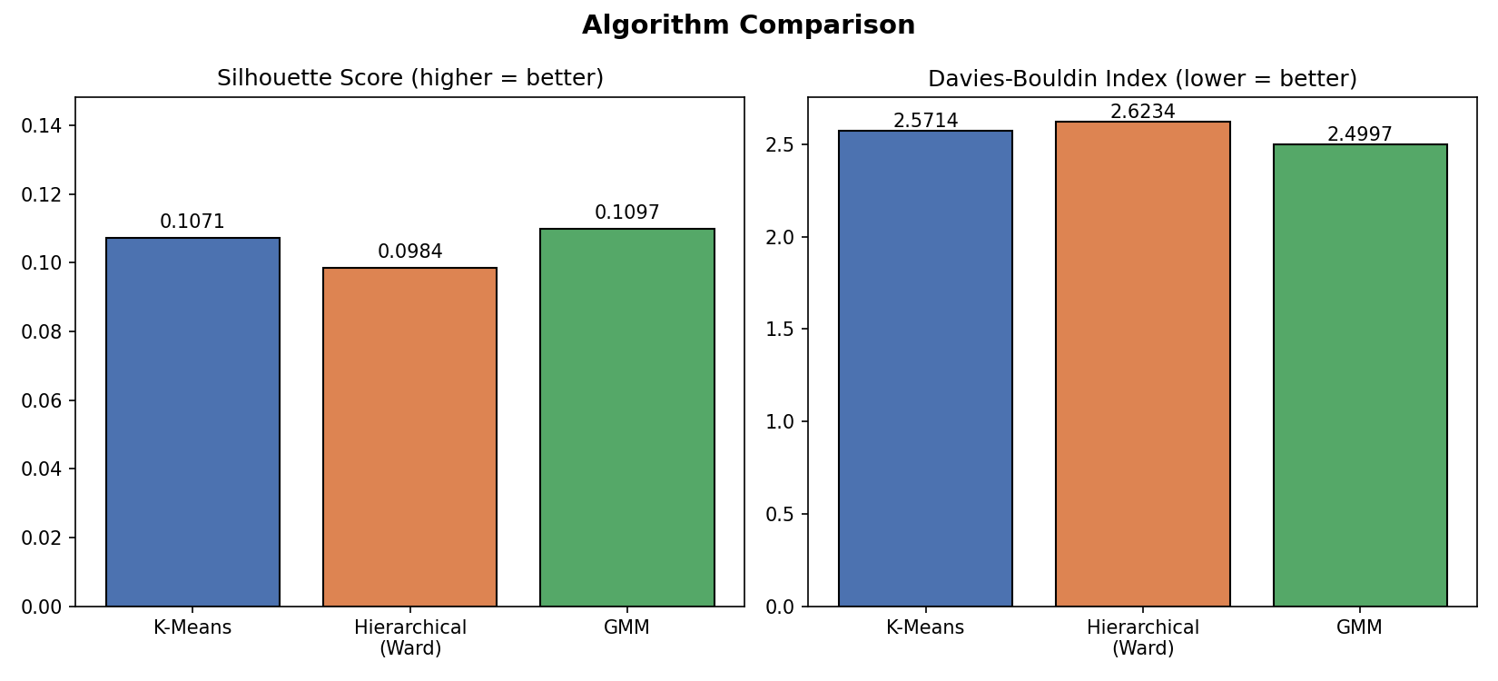

5.8 Feature Sensitivity Analysis
A sensitivity analysis was conducted by reducing the feature set to only three key biomarkers: BMI (associated with Obesity), Glucose (associated with Diabetes), and Blood Pressure (associated with Hypertension). K-Means with K=3 on these three features achieved a Silhouette Score of 0.3649 and a Davies-Bouldin Index of 1.0176 — a dramatic improvement over the 9-feature model (Silhouette: 0.1071, DBI: 2.5714). Cross-tabulation showed that the 3-feature model achieved strong separation: Cluster 0 captured 390 Hypertension patients, Cluster 1 captured 384 Obesity patients, and Cluster 2 captured 141 Diabetes patients.
Figure 12: 3-Feature vs. 9-Feature K-Means Comparison
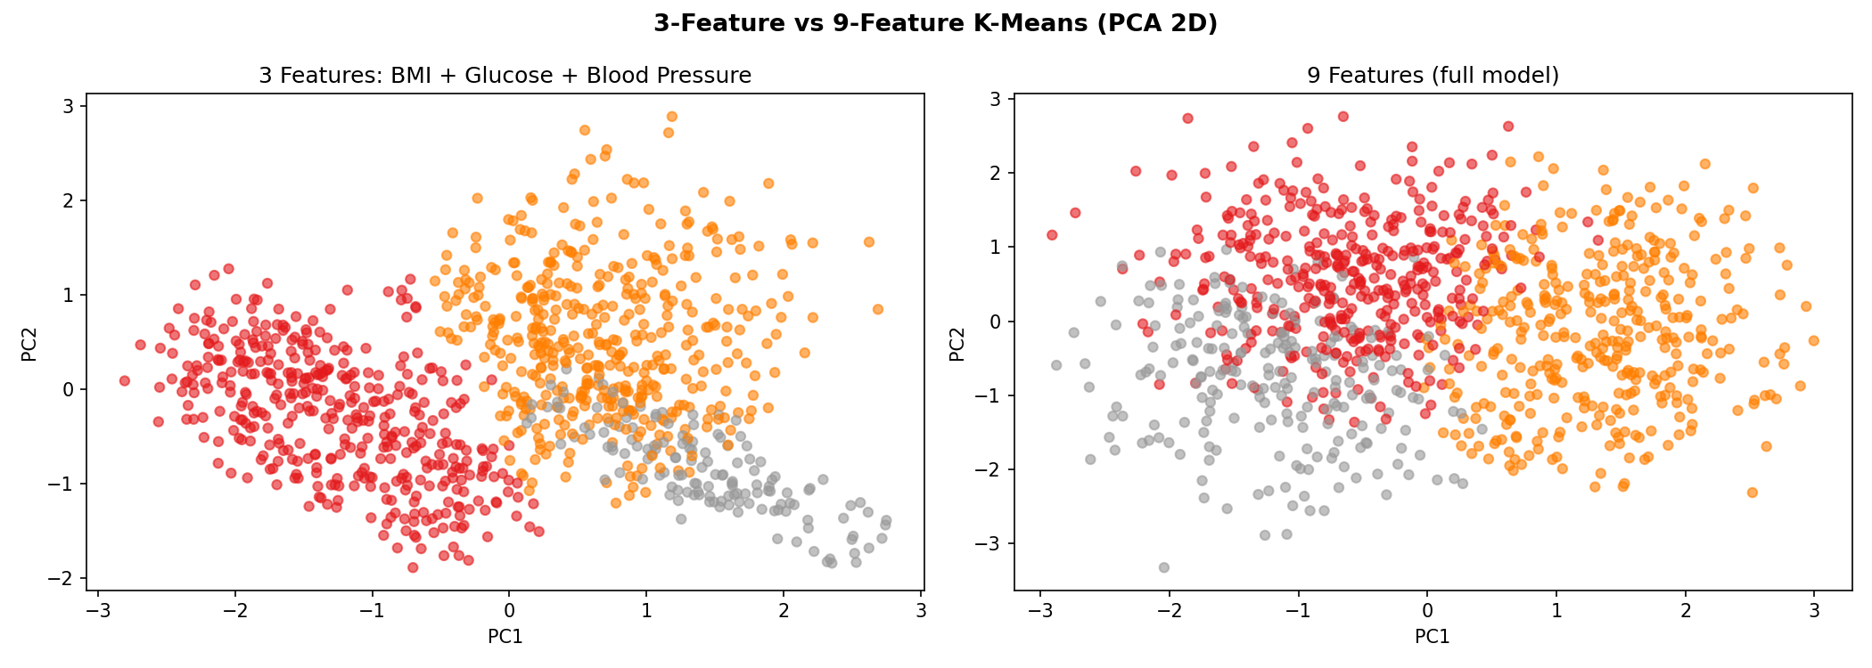

5.9 Cluster Profiling
The radar chart below shows the normalized mean feature values for each discovered disease group. Key findings include: the Diabetes group has the highest Glucose levels and Age, the Hypertension group has the highest Blood Pressure and lowest BMI, and the Obesity group has the highest BMI and Cholesterol. These profiles align with known clinical characteristics of each condition, validating the meaningfulness of the clustering results.
Figure 13: Disease Group Profiles – Radar Chart
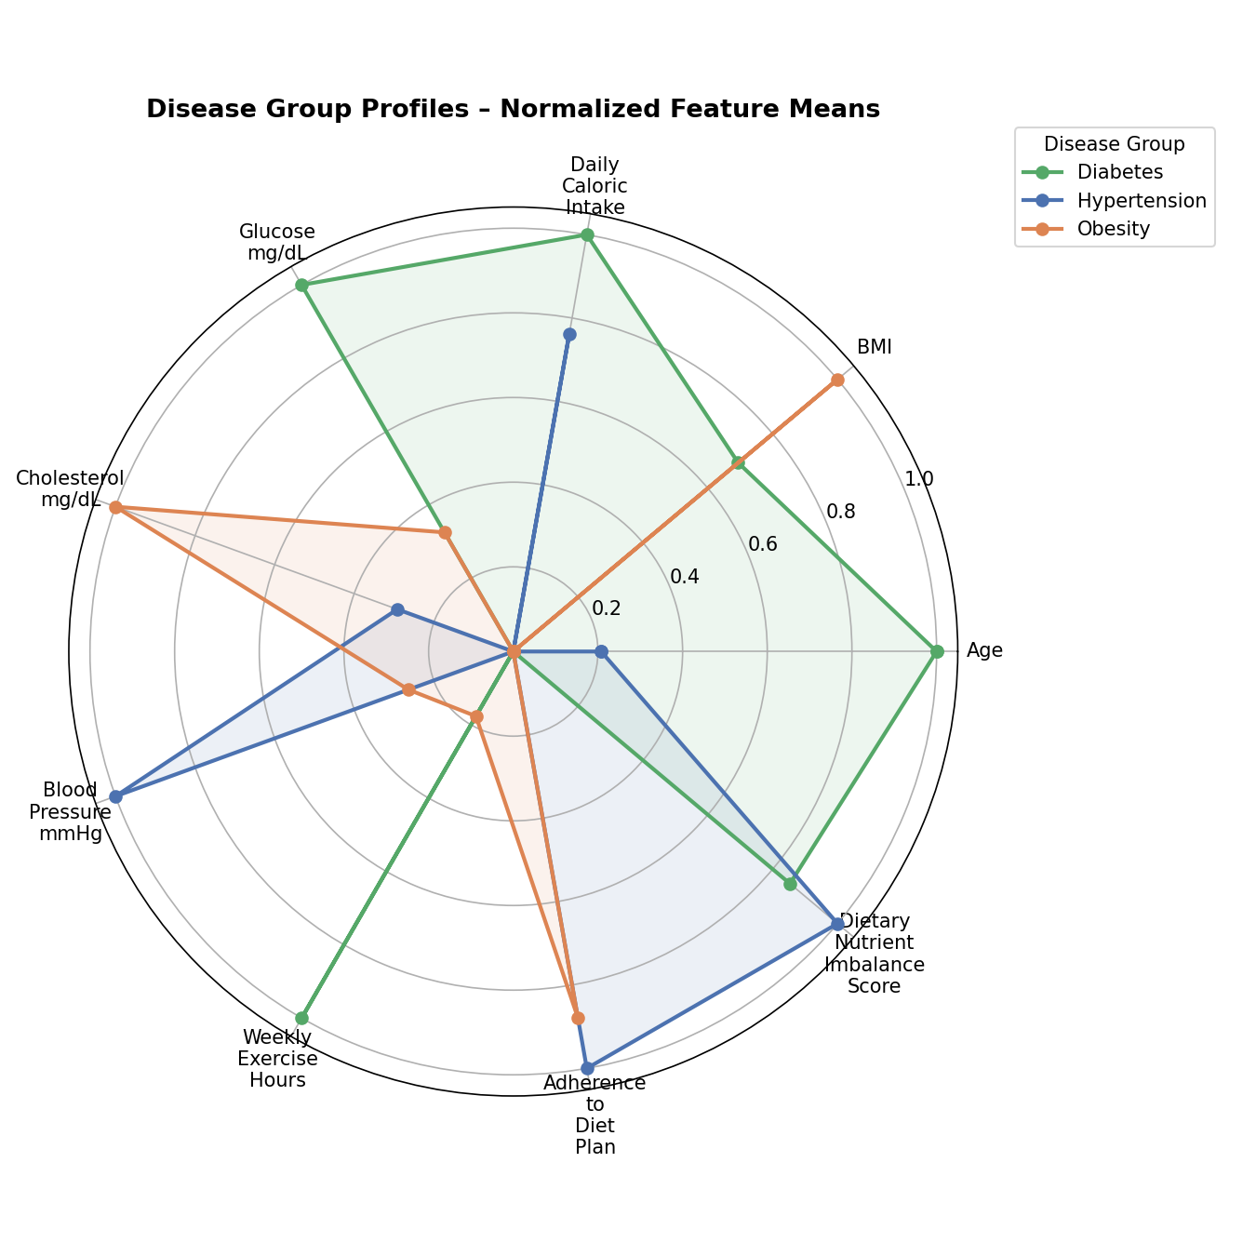
Table 7: K-Means Cluster Means per Disease Group
Feature | Diabetes | Hypertension | Obesity
Age | 54.61 | 49.22 | 47.81
BMI | 30.12 | 20.82 | 34.22
Daily Caloric Intake | 2663.43 | 2571.54 | 2276.39
Cholesterol (mg/dL) | 219.70 | 223.38 | 232.32
Blood Pressure (mmHg) | 141.48 | 157.47 | 145.69
Glucose (mg/dL) | 152.36 | 100.51 | 117.36
Weekly Exercise Hours | 5.75 | 4.93 | 5.07
Adherence to Diet Plan | 71.05 | 76.30 | 75.67
Nutrient Imbalance Score | 2.60 | 2.67 | 2.20

6. Conclusion and Future Work
This progress report presented the development and evaluation of an unsupervised machine learning framework for discovering disease subgroups from health data. Four clustering algorithms were applied to a 1,000-record health dataset containing clinical biomarkers, dietary indicators, and lifestyle measures: K-Means, Hierarchical Clustering (Ward linkage), DBSCAN, and Gaussian Mixture Models (GMM). The results demonstrate that GMM achieved the best overall performance with a Silhouette Score of 0.1097 and a Davies-Bouldin Index of 2.4997, producing clinically interpretable clusters with high purity when validated against known disease labels—up to 97.5% for the Hypertension subgroup.
A key finding is that DBSCAN was found to be unsuitable for this dataset due to its uniform density distribution, consistently producing only a single cluster across all tested epsilon values. In contrast, both partition-based (K-Means) and probabilistic (GMM) approaches successfully identified three distinct disease subgroups that align with known clinical categories: Hypertension, Obesity, and Diabetes. The feature sensitivity analysis revealed that focusing on three key biomarkers—BMI, Glucose, and Blood Pressure—dramatically improves cluster separation (Silhouette: 0.3649 vs. 0.1071), suggesting that targeted feature selection based on clinical domain knowledge is a highly effective strategy for disease subgroup discovery.
The cluster profiling results confirmed medically interpretable subgroup characteristics: the Diabetes subgroup exhibits the highest glucose levels and older average age, the Hypertension subgroup shows the highest blood pressure with the lowest average BMI, and the Obesity subgroup has the highest BMI and cholesterol levels. These findings validate the framework’s ability to discover meaningful disease subgroups without relying on labeled data, demonstrating the practical utility of unsupervised learning for health data analytics.
For the remaining phases of this project, the team plans to pursue the following directions: (1) adopt the 3-feature reduced model (BMI, Glucose, Blood Pressure) as the primary analytical framework given its superior separation performance; (2) explore additional feature engineering strategies including interaction terms and clinically validated health indices; (3) investigate ensemble clustering approaches that combine the strengths of K-Means and GMM; (4) conduct a detailed comparison of our results with the specific studies in the literature review that used similar health datasets, particularly [1] and [3]; (5) evaluate the potential for deriving personalized health recommendations based on discovered subgroup profiles; and (6) prepare the final report and presentation with comprehensive documentation of all experimental findings, clinical interpretations, and actionable insights for public health decision-making.

References
[1] R. Tatoli, L. Lampignano, I. Bortone, and R. Donghia, “Dietary patterns associated with diabetes in an older population from Southern Italy using an unsupervised learning approach,” Sensors, vol. 22, no. 8, 2022.
[2] L. Li, H. Momma, H. Chen, and Y. Xu, “Dietary patterns associated with the incidence of hypertension among adult Japanese males: application of machine learning to a cohort study,” European Journal of Nutrition, 2024.
[3] H. Sun, L. Zhu, P. Wang, and Y. Cui, “Dietary patterns and obesity are associated with type 2 diabetes risk in elderly Chinese men: a machine learning approach,” Frontiers in Public Health, vol. 13, 2025.
[4] M. Gjoreski, S. Kochev, and N. Reščič, “Exploring dietary intake data collected by FPQ using unsupervised learning,” in Proc. IEEE International Conference on Big Data, 2019.
[5] M. Côté, J. M. Hutchinson, M. Touvier, and B. Srour, “Associations between dietary pattern networks derived from machine learning algorithms and cardiovascular risk in the NutriNet-Santé cohort,” The Journal of Nutrition, 2025.
[6] N. J. D’Souza, K. Downing, G. Abbott, and L. Orellana, “A comparison of children’s diet and movement behaviour patterns derived from three unsupervised multivariate methods,” PLoS ONE, 2021.

